Export Data

<https://www.geeksforgeeks.org/export-data-from-mongodb/?ref=lbp>

1. For exporting data in JSON format

mongoexport --uri="mongodb://localhost:27017/mapping"

--collection=studentCollections --out=C:\Users\user\Desktop\studentCollectionData.json

Uri : the for database connection and specify the database name

Collection: which collection data needs to be exported .

Out : output should be stored in which location with file name.

If the same file is used for other export also it will delete all the data from the data prior added.

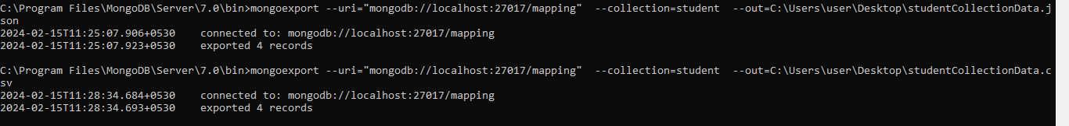

1. For exporting data in CSV format

mongoexport --uri="mongodb://localhost:27017/mapping"

--collection=student --out=C:\Users\user\Desktop\studentCollectionData.csv

Import Data

1. you can import JSON files using mongoimport tool.

mongoimport --db myDatabase --collection dummyData --file "D:/MongoDB Commnads/data.json"

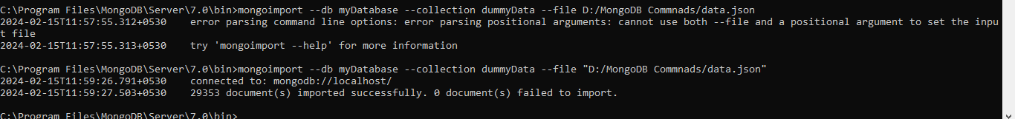

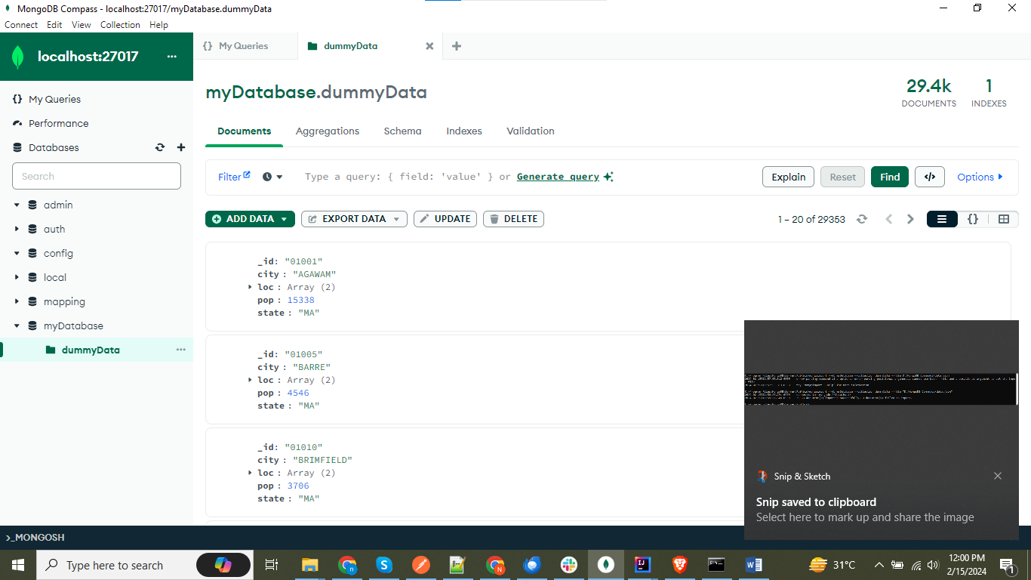

1. Now for .csv file

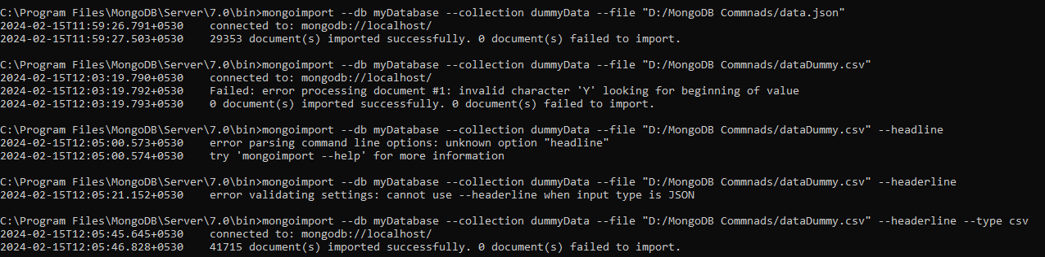

In .csv file we need to be carefully while working it we don’t specify that the first row is not the part of json to be stored in the collection. We have to provide –-**headerline**

mongoimport --db myDatabase --collection data --file "D:/MongoDB Commnads/data.json" --headerline --type csv